1. App I Use Daily: Myntra
I use Myntra regularly for shopping. I think these are three ways it increases its visibility online:
- Instagram: Myntra posts fashion reels, outfit ideas, and sale updates that attract a lot of people.
- Influencers: Many fashion creators wear and recommend clothes from Myntra, which encourages people to visit the app.
- Google Search: Whenever I search for clothes or fashion brands on Google, Myntra usually appears in the top search results.

2. Features on the Flipkart Homepage
When I visited the Flipkart homepage, I noticed a few sections that keep users engaged:
- Sale Banners: The homepage shows big banners for ongoing sales and discounts, which immediately grab attention.
- Recommended for You: Flipkart suggests products based on what users have viewed or purchased before.
- Trending Deals: It also highlights popular products and limited-time offers, making users want to explore more.

3. Google Trends (IPL, World Cup & K-pop)
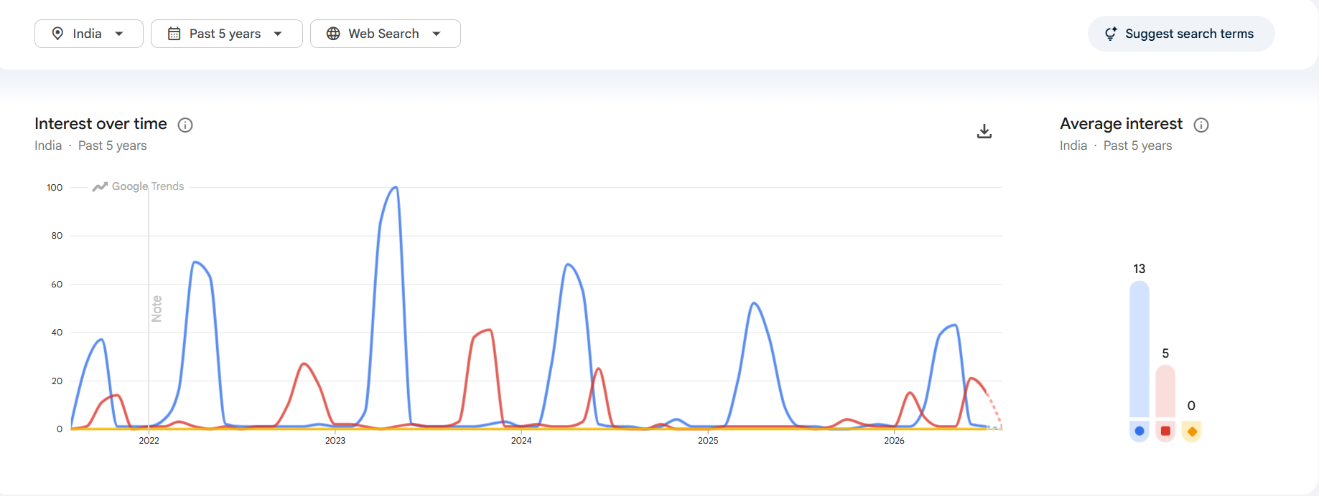
After comparing these three topics, I noticed that IPL has the highest search interest in India over the last 12 months.
I think this is because cricket is very popular in India, and during the IPL season, people search for match schedules, live scores, team news, and player updates almost every day.

4. Instagram Food Blog Post

Caption
Tried this delicious meal today and it was amazing! If you're someone who loves exploring new cafes and tasty food, you're in the right place. Follow my page for more food recommendations, honest reviews, and hidden food spots.
Hashtags
#FoodLover #Foodie #FoodGram #CafeHopping #FoodRecommendations

